**Computer Organization Fall 2024**

**HKBU-BNU United International College**

**Lab 5: The Microarchitecture**

# Lab Objective

To understand how the microarchitecture works.

# Introduction

The microarchitecture transforms an ISA into an implementation. The ISA specifies the set of instructions the computer can carry out. The microarchitecture specifies how these instructions are carried out by a collection of circuits connected together in a certain way. An ISA can have more than one implementations. For example, x86 has been implemented by several different microprocessors over the year.

In this lab, we will study the microarchitecture of an example von Neumann mchine (Figure 1): **the LC-3 computer**. LC-3 has **a memory address space of 216** and **its addressability is 16 bits**. It has an ALU that has a word length of 16 bits and can perform ADD, AND and NOT operations. The LC-3 has **eight general purpose registers (R0, R1, …, R7)**, each containing 16 bits. In the LC-3, we have two most basic input and output devices, the keyboard and the monitor. The control unit of LC-3 has **PC for containing the address of the next instruction and IR for containing the current instruction**.

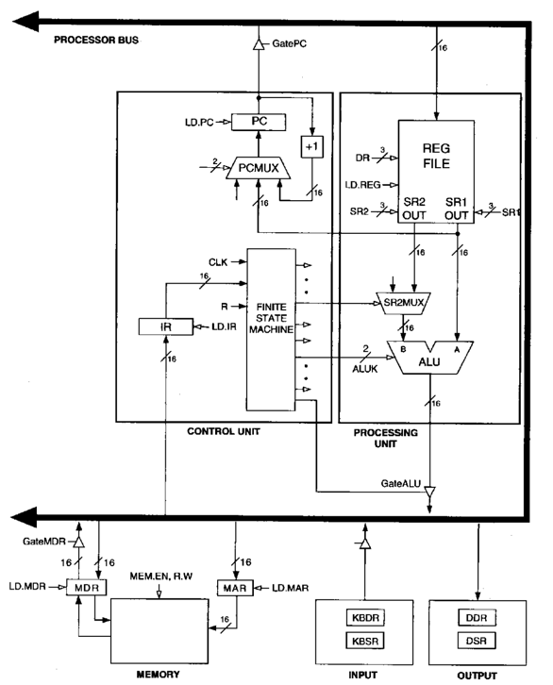

Figure 1 The Microarchitecture of the LC-3 Computer

# Lab Instruction

**Step 1: Download and run the LC3 Microarchitecture Simulator: LC3uArch.jar**

**Step 2: Load the machine code “foo.obj” that contains three instructions: ADD, LDR and JMP.**

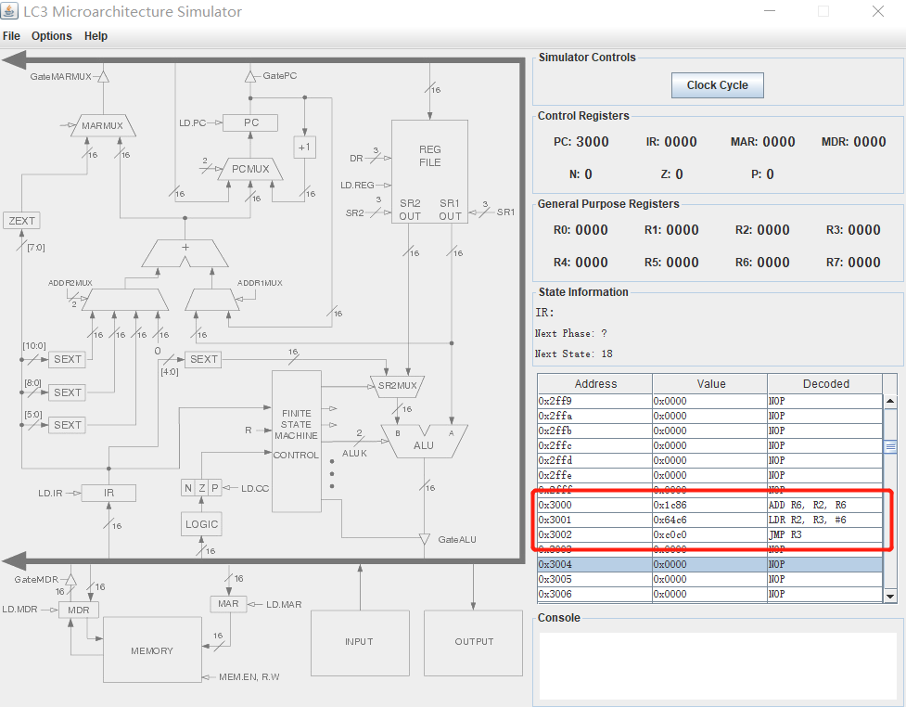

**Step 3: Click the “clock cycles” button to see how the instruction is being executed step by step.**

# Lab Exercise

Select any ISA instruction you have learned in the class, and analyze the process of the fetch-decode-execution cycle step by step. It should contain change of the state and change of the registers values, and PC, IR, MAR and MDR.

# Submission

Upload the report file (.doc, or, .pdf) into space. Please name the report file with your student ID.